The All Year Flower Bed at Middle Bourne Lane
Plant List, 2017

Perennials
Agastache Blackadder
Achillea Coronation Gold
Gaura lindheimeri
Geranium macrorrhizum Album
Phlomis russelliana
Kalmeris incise Charlotte
Miscanthus Malepartus
Sedum Autumn Joy
Succisa pratensis Small Blue

Shrubs
Buddleja Lochinch
Berberis thunbergii atropurpurea,
Ceanothus Skylark
Cercis Forest Pansy
Cistus corbariensis
Daphne odora Aureomarginata
Lavandula angustifolia
Perovskia Blue Spire
Rosemary Mrs Jessop
Rosa rugosa Alba
Sarcococca Winter Gem
Viburnum opulus

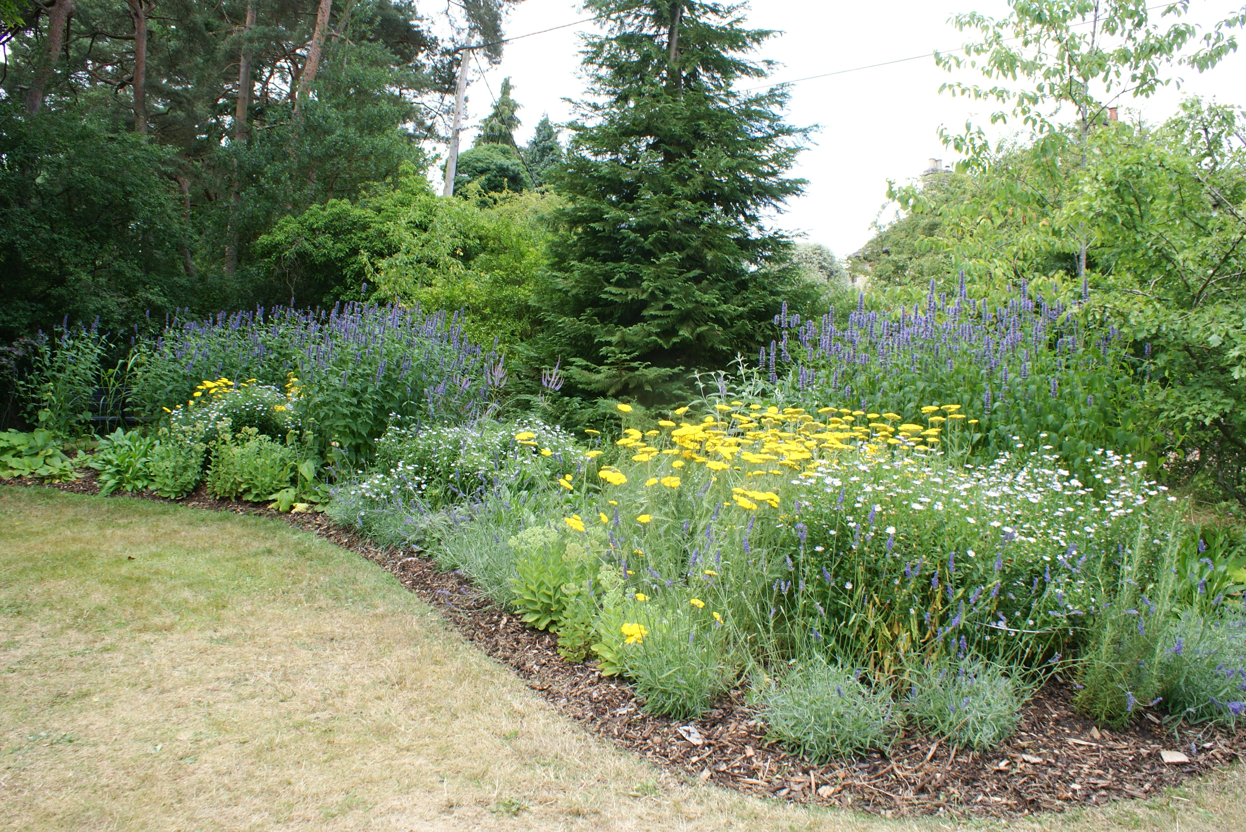
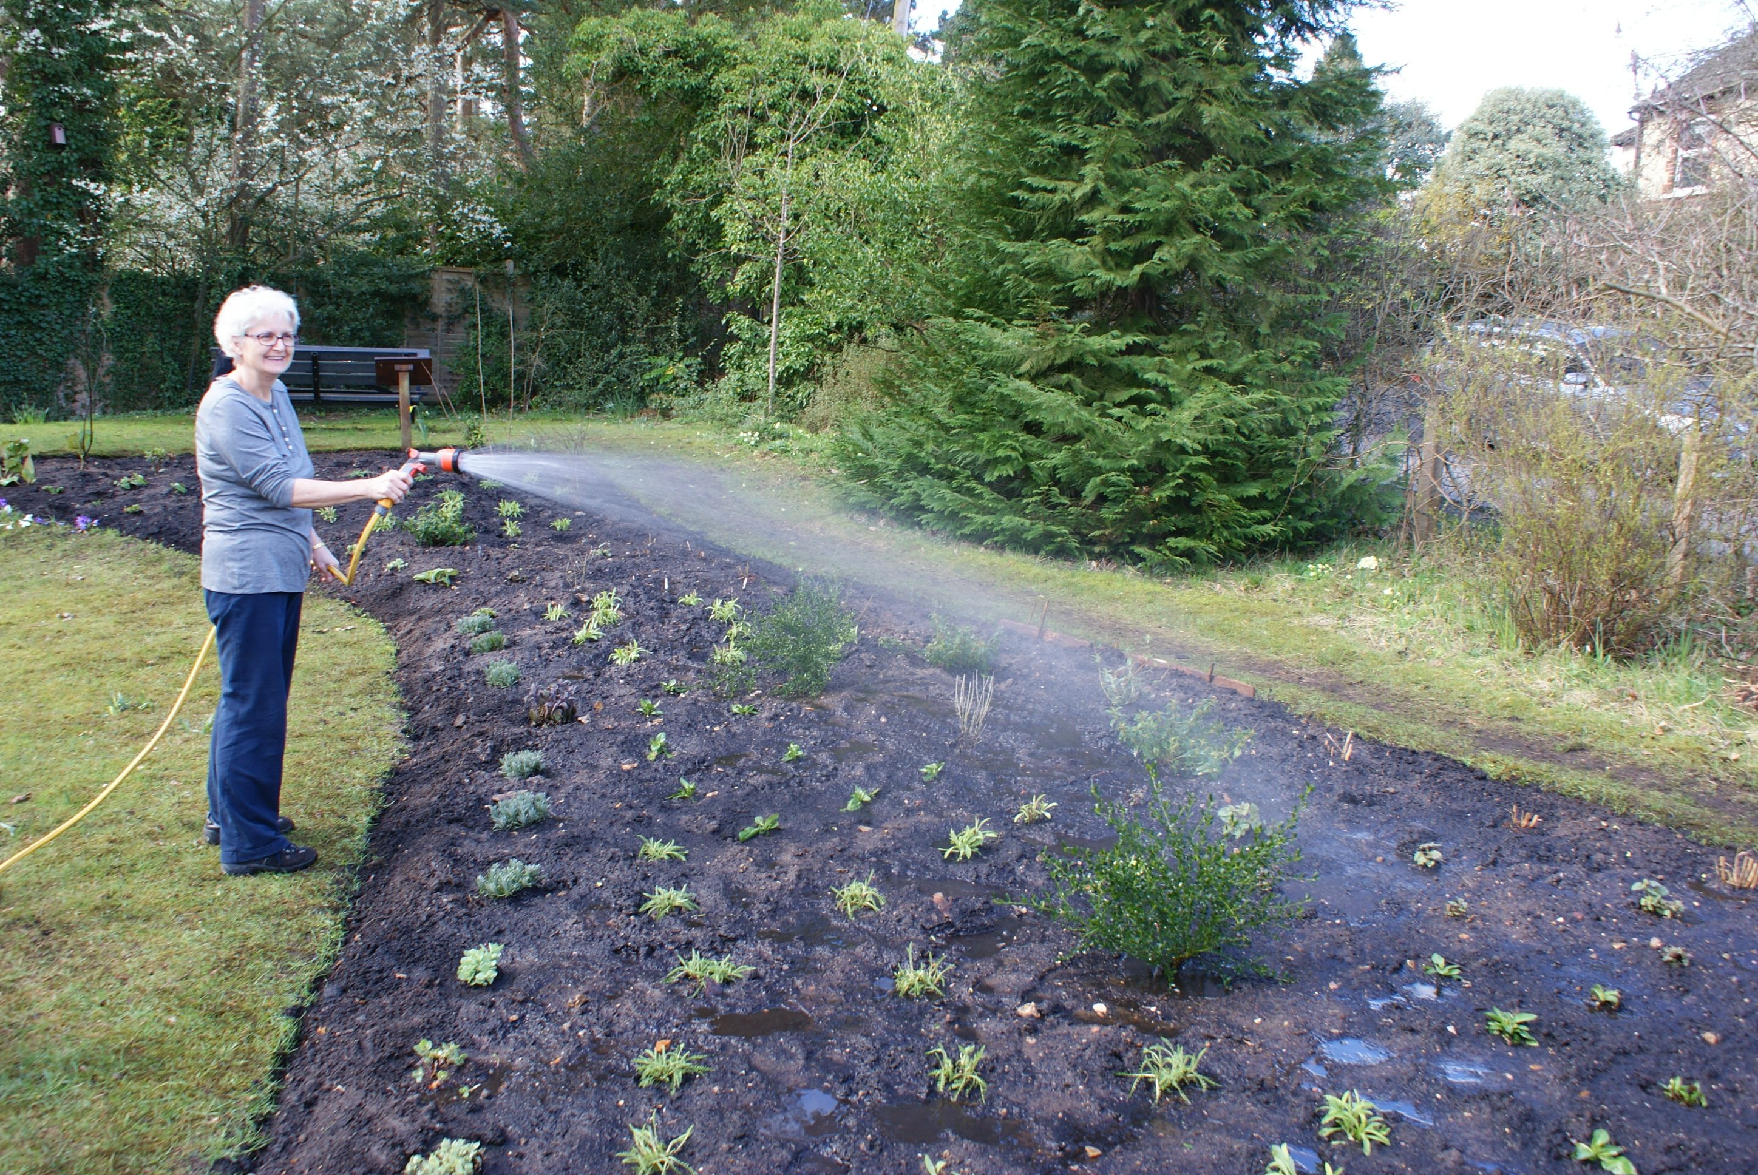

July 2017
February 2017

