**Great Loss to Local Conservation Activities**

Many in the Farnham area were greatly saddened by Dr Alan Stanley Cockett's death in 2011, aged 69, following a short illness. Universally known as Stan, he was well known for his commitment as a volunteer to local conservation projects and ten years ago founded The Bourne Conservation Group.

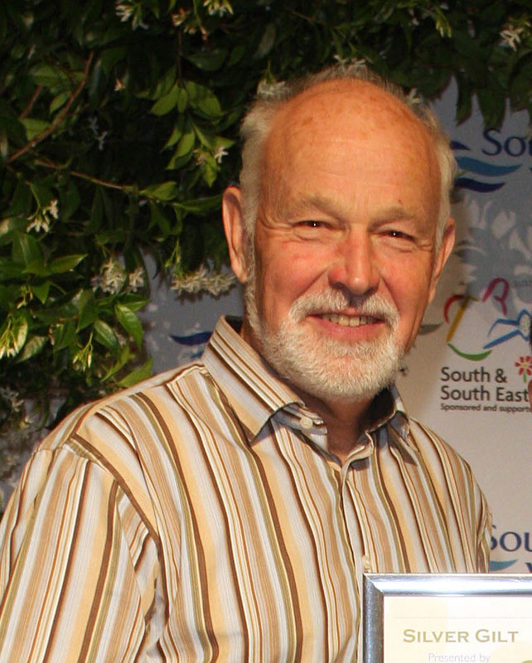

Both as a geologist operating in the oil industry and as a long term member of international conservation charity “Earthwatch”, he was well acquainted with environmental issues. It was, however, while working as a Waverley volunteer on Frensham Common and exploring other open spaces, that he became acutely aware of the need for urgent local action to maintain and improve their condition. He later recounted how he often walked on the public footpath through the once attractive Paradise Wood (off Greenhill Road) and noticed that it was becoming a dark, dank, depressing, perhaps threatening place, of little value to wildlife, due to the uncontrolled growth of laurel, rhododendrons and holly. He resolved to do something about it and, when Earthwatch launched a scheme whereby volunteers were offered free training in return for undertaking a local project, he applied successfully. In his usual self-effacing way he said “I got a free holiday helping to carry out an environmental survey in an Italian National Park near Naples, and The Bourne got an embryonic conservation group.”

Established entirely thanks to Stan’s initiative, The Bourne Conservation Group undertook its first work session in October 2002 and, throughout its subsequent life, has returned many times to Paradise Wood to open up the footpaths and progressively deal with the invasive vegetation. Under his leadership the Group went from strength to strength and took on a wider range of tasks to enhance the local environment for the benefit of wildlife as well as the human population. Not content with undertaking this considerable task, he also joined the group newly formed by the RSPB to assist in its heathland restoration project at Farnham Heath, and became one of its most active and loyal volunteers. He acted as Footpath Warden for the rights of way throughout the reserve.



***Working on a final task for the community – the paving of the MBL gateway***

Tough and fit, Stan liked nothing better than being out and about in all weathers tackling some physically demanding task. He loved to be involved in making a difference. He neither liked bureaucracy nor formal occasions but was nevertheless proud and delighted in 2009 to travel to Brighton to receive a Silver Gilt award for the Middle Bourne Lane Community Garden entered in the South East in Bloom competition. Unsurprisingly for someone who contributed so much to the well-being of the local environment, he was widely known throughout the conservation community and beyond. He was a warm character and all who worked with him responded to his down to earth, friendly manner and quietly distinctive brand of humour.

**Founder of Bourne Conservation Group commemorated**

A small ceremony was held on 29th May 2013 in Paradise Wood, off Greenhill Road, to unveil a rustic seat placed to commemorate Stan's life.. The seat was provided and installed through a joint effort between The Bourne Conservation Group (BCG) and the county council, which greatly appreciated his work as a volunteer. The footpath through the wood has been named after him to become the latest in the network of named paths in The Bourne.

Noel Moss, the Chairman of BCG, welcomed members of BCG and representatives of Surrey County Council, Waverley Borough Council, The Bourne Resident’s Association and other organisations including the RSPB, for whom Stan had also been a volunteer. He especially welcomed Yvonne Cockett, Stan’s widow, and Justin, their son.

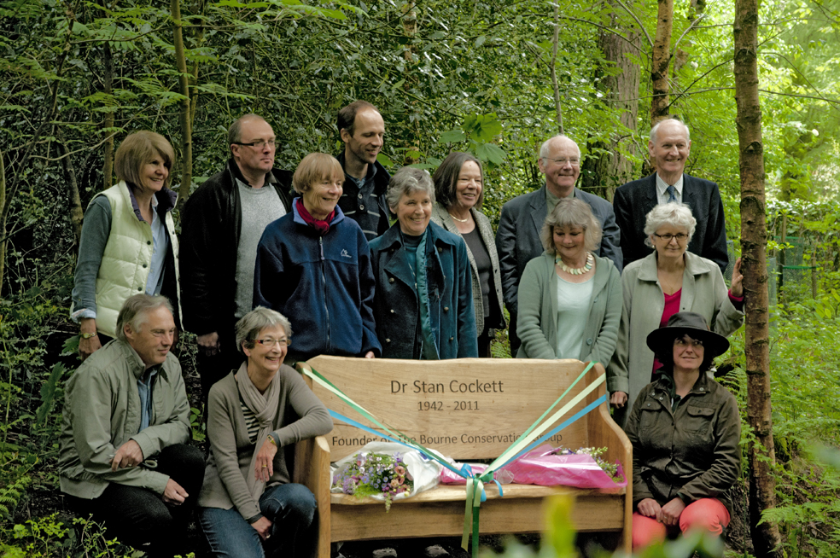

Noel reminded those present that Stan was a geologist who travelled widely and, as such, was vitally interested in the environment in which he lived and worked. He was a long term member of Earthwatch, an international charity based in the UK that enables volunteers to work with scientists on environmental matters. In 2002 they launched a scheme whereby volunteers went free to one of their field areas in return for setting up a local conservation project.

This coincided with Stan walking through Paradise Wood. He described it at that time as mixed woodland under the management of Waverley Council. It was heavily invaded by laurel and rhododendron which made it a dark, depressing, perhaps even threatening place of little value to wildlife and plants. It struck him that with minimal work by volunteers this small area could become a valuable wildlife habitat and local amenity. So he got the Group up and running under his own initiative, using the Residents'Association to recruit the first volunteers, and one of its earliest projects was in this very wood.

Noel finished by saying that Stan did an enormous amount for the local area and it was entirely fitting that we should commemorate him and his work in this way. He then introduced Councillor Carole Cockburn, who had known Stan well.

Carole said that it was here, early on in her stint as mayor, that she witnessed Stan's hands-on approach to conservation. He was unstoppable. The work impressed her so much that she became an instant fan of the award-winning Bourne Conservation Group. BCG continues to influence decisions throughout the town. Little did Stan know that all the contacts he built up with local organisations would result in a real appreciation of the importance of the green environment and a desire to protect and enhance it. She said that the excellent work on green infrastructure, which the BCG was providing for the Neighbourhood Plan, would be another lasting tribute toStan's initiative. She described him as an inspirational man.

Cllr Cockburn and Yvonne Cockett then cut the ribbon to open the seat. They were both presented with bouquets by Noel Moss at the end of the ceremony.