Old Church Lane: George Sturt and W.H.Allen
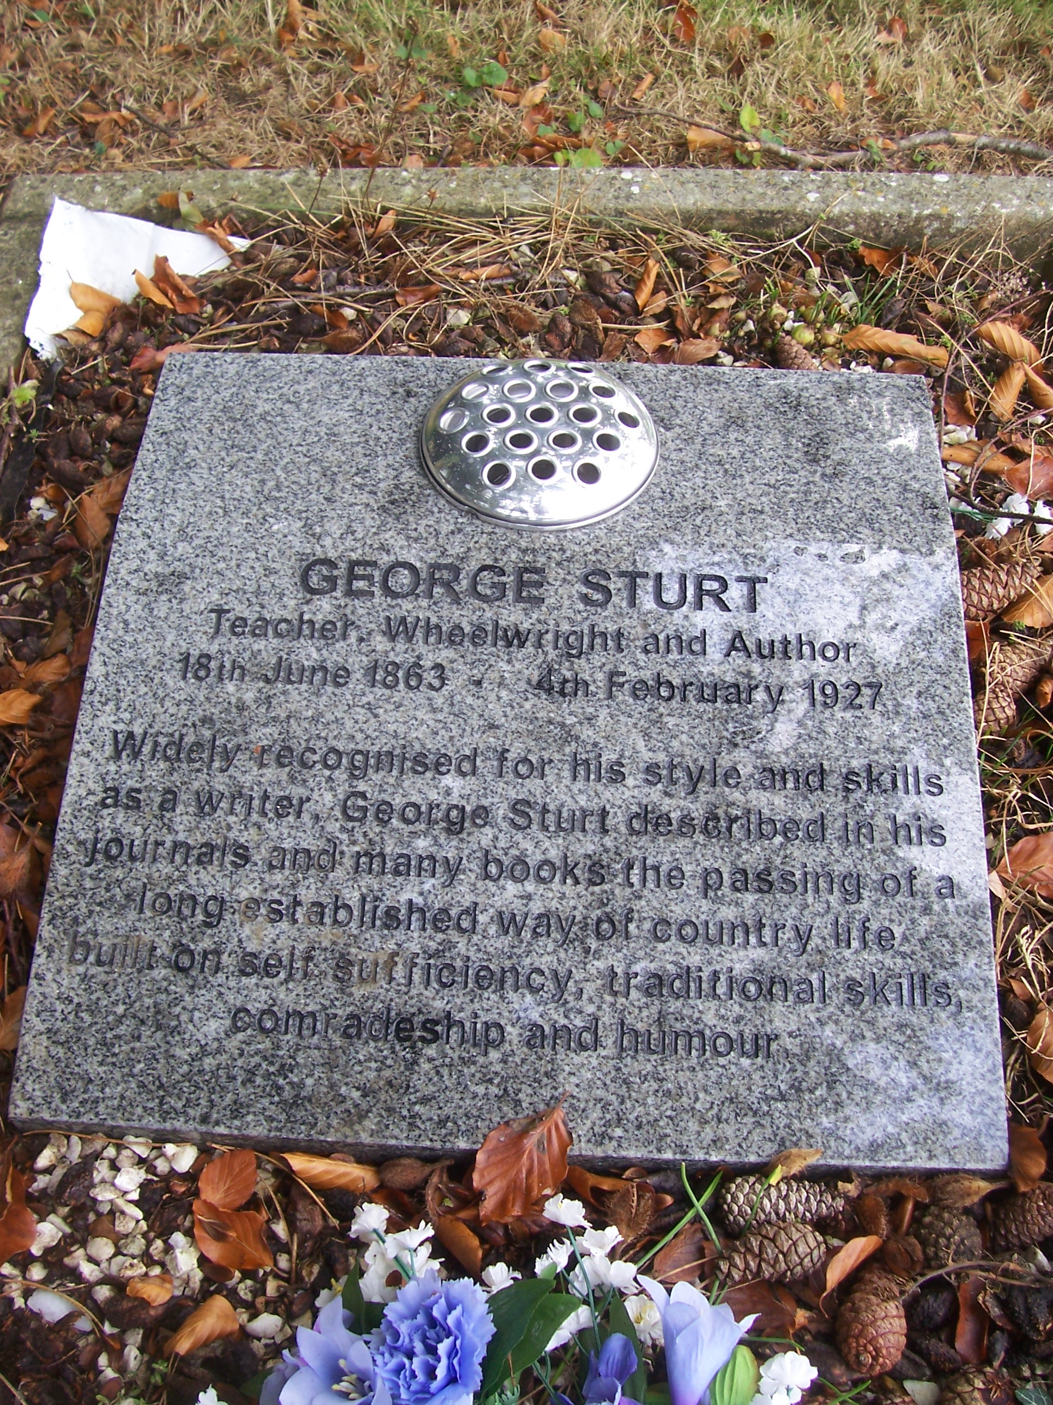 | In addition to being the 250th. anniversary of William Cobbett’s birth, 2013 marked the 150th. anniversary of George Sturt’s birth, an event which the Bourne Conservation Group has done its bit to commemorate by incorporating into its programme for National Heritage weekend in September a brief, wet visit to Vine Cottage with short reading from Memoirs of a Surrey Labourer describing George and Fred Grover working in the garden in similar weather. Since his death in 1927, Sturt’s grave, and those of his sisters Mary and Susan, in Green Lane Cemetery have been unmarked but talks between Richard Sandars and the Town Council have resulted in the tidying up of the three graves and the installation of a commemorative stone.
Also born in 1863, some three months after Sturt, was William Herbert Allen who was for forty years the Head of the Farnham Art School. The two shared similar interests (Sturt joined Allen’s outdoor watercolour club) and both became friends, with Allen and his wife regularly visiting Sturt at Vine Cottage towards the end of George’s life. “Allen came last evening, bringing for me to see his recent water colours from Binsted – interiors of barns, granaries, a smithy...” The genuine affection between the two men is expressed in Sturt description of Allen patting his arm as he leaves as if trying to “convey by touch what (he) could not express in words”. Allen produced a large number of paintings and sketches of Farnham and the surrounding areas, including three chalk sketches of Sturt and three watercolours of ‘Sturt’s Lane’ – now Old Church Lane. These and other works by Allen can be seen on the website for the Allen Gallery www.hants.gov.uk/allen-gallery/w-h-allen.htm. In 1905 Allen married Adelaide Maria Sothern at the Old Bourne Church and the couple moved into Strangers Corner on the Tilford Road Built for them by Harold Falkner. previously a student of Allen’s.
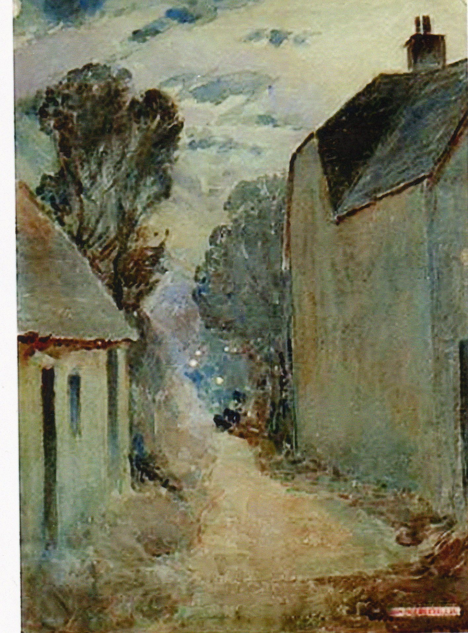 | 