GEORGE STURT 1863 – 1927
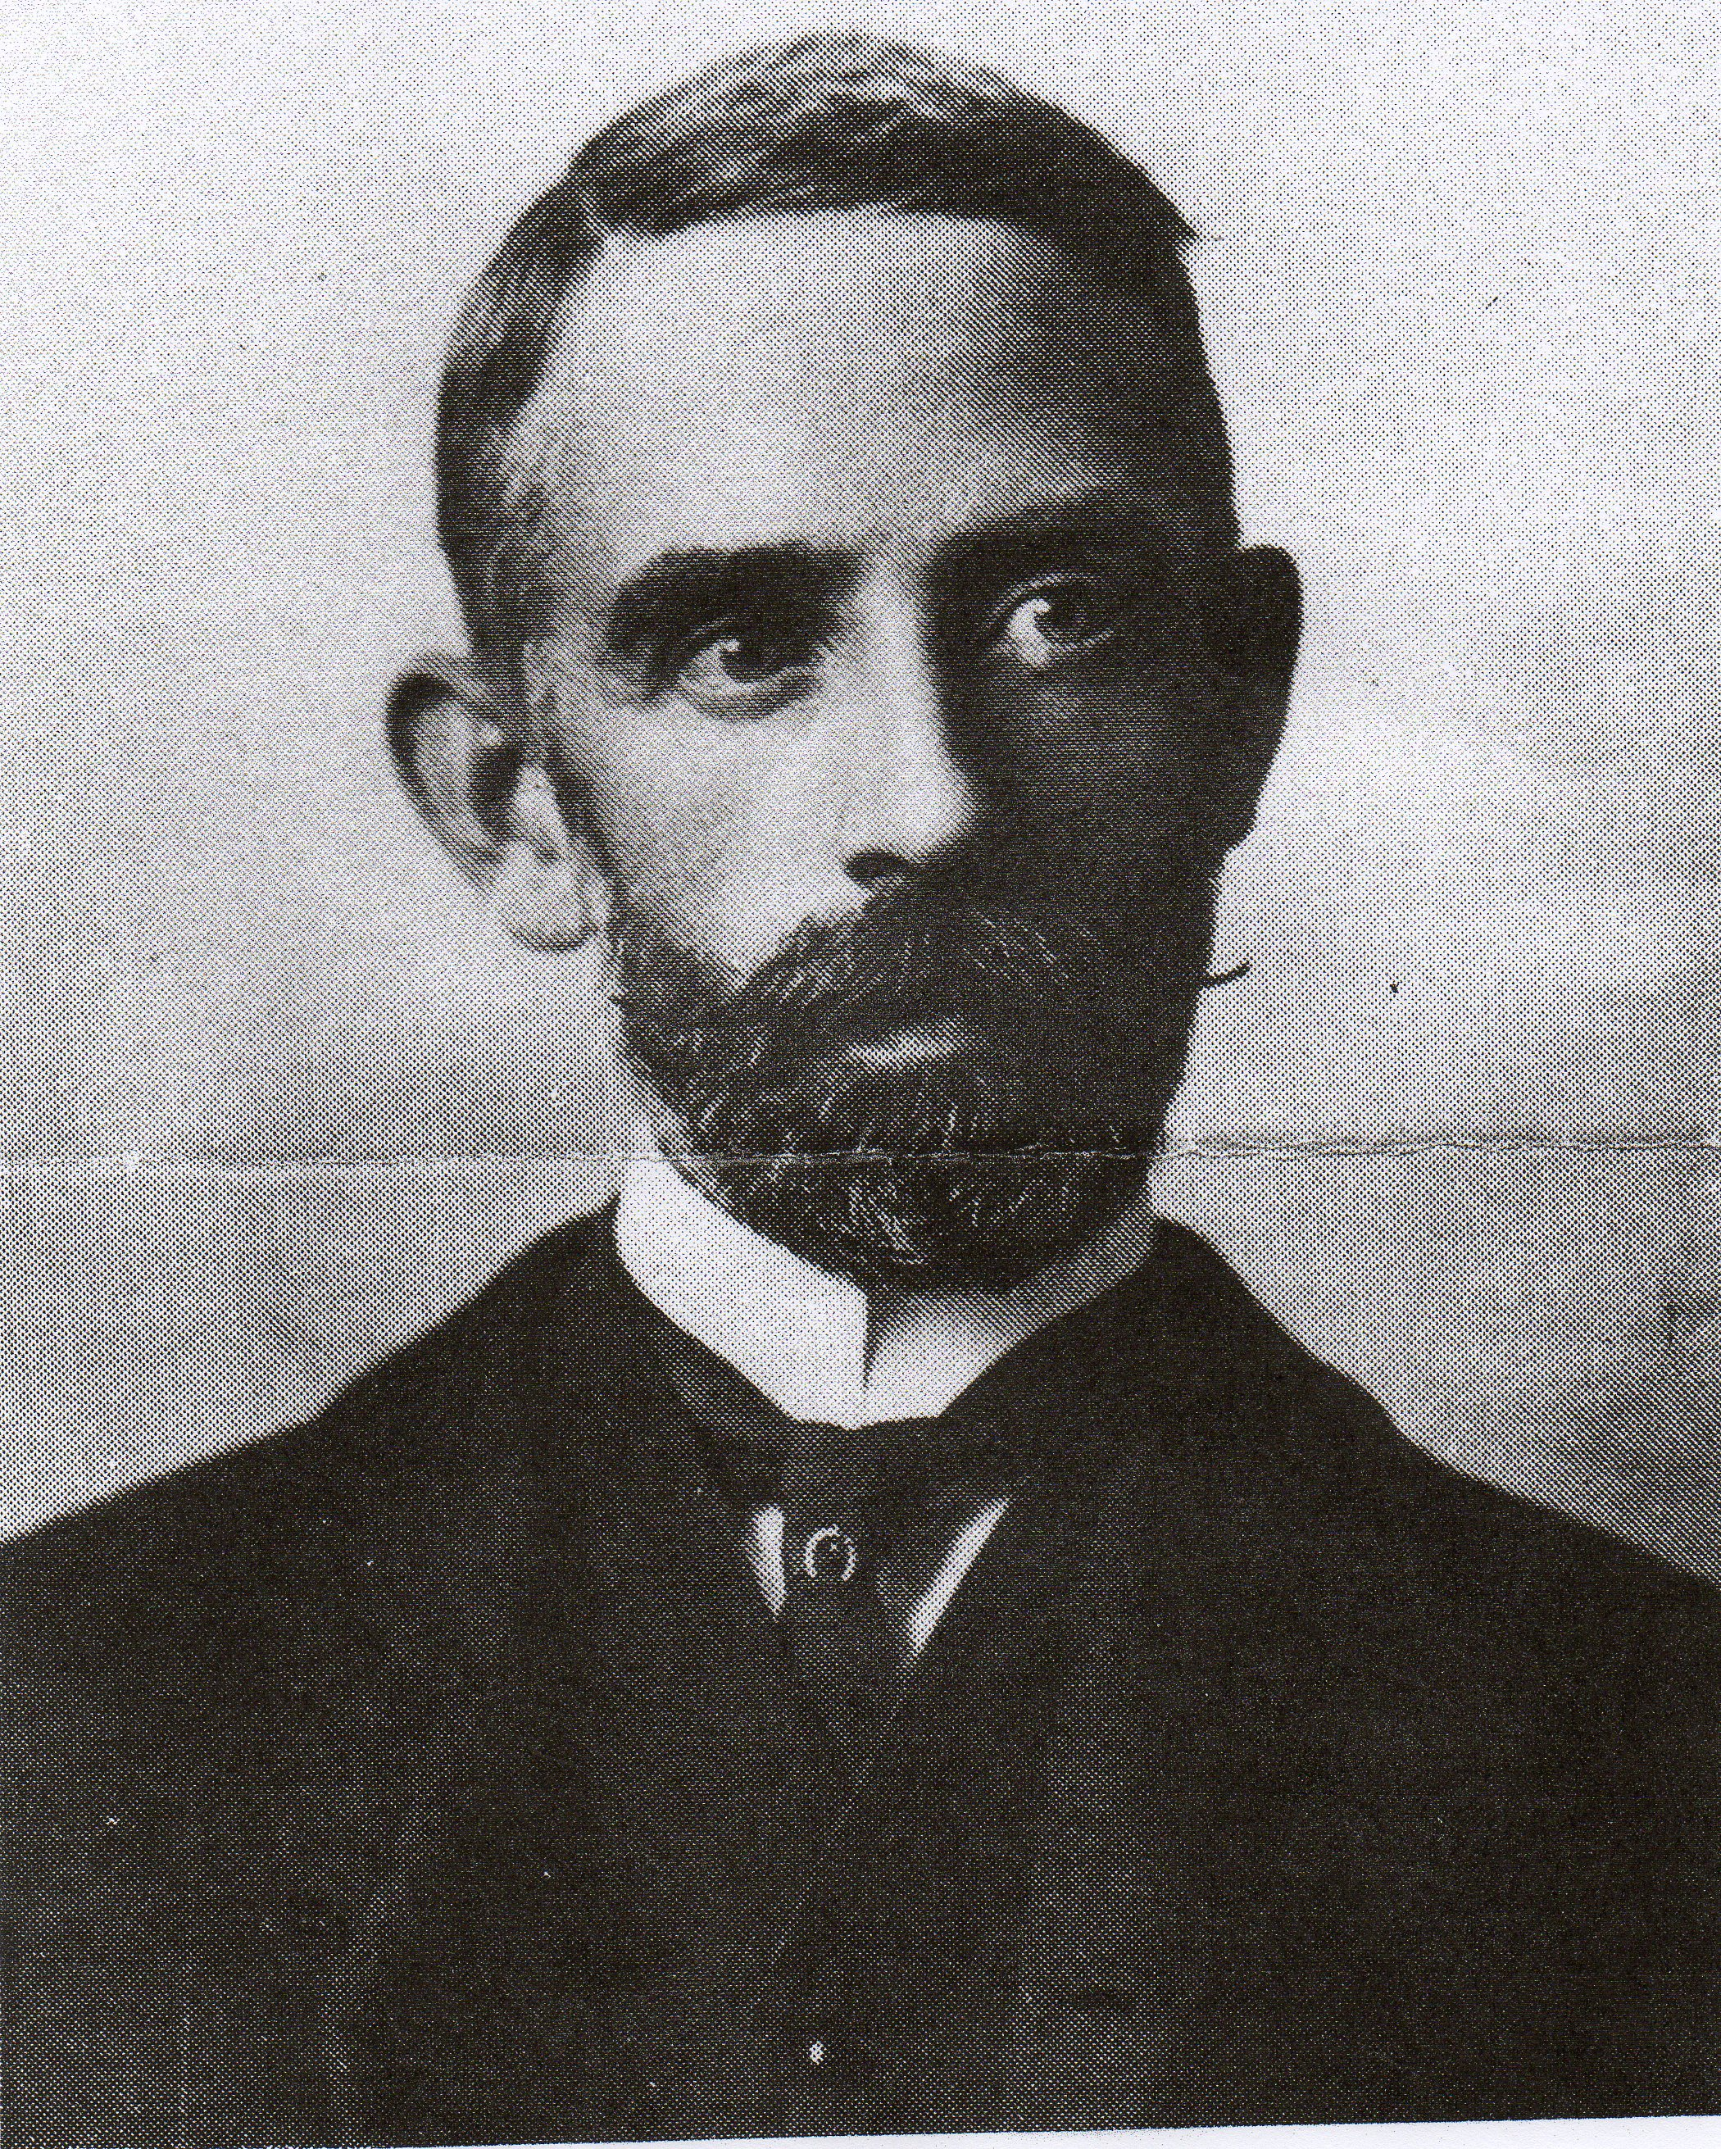Writing in celebration of William Cobbett’s 250th anniversary in your March edition, Charles Stuart, Chairman of the William Cobbett Society, makes a passing reference to another of Farnham’s famous sons, George Sturt. Generally less well known than Cobbett, George Sturt was an inquisitive and methodical observer of the social changes happening between the end of the nineteenth century through to the time of his death in 1927, whose writing attracted the attention three eminent literary critics, F.R Leavis, Raymond Williams and Richard Hoggart. In his book “Townscape with Figures” Hoggart, himself a sometime Farnham resident, remarked of the town that ”few such places have had two native sons such as Cobbett and Sturt, each of whom, though in different forms and manners, celebrated their small town in an intimate, loving but wholly unparochial way”. Of Sturt he wrote with affection “....he lets his generalisations emerge from the ‘thisness’ of his accumulated detail; like one who is blind for the time being, he runs his hands carefully and respectfully over the great mass of (his) material until it yields its shape to him; then he quietly offers it to you”.
In his introduction to Sturt’s reminiscences of growing up in Farnham - A small boy in the sixties (published in 1927 shortly after his death) Arnold Bennett, whom Sturt had met at a friend’s house in Richmond and who encouraged him to take up keeping a journal again, describes Sturt as “a dark man with irregular features, fine benevolent eyes, ever so slightly under average height; modest but neither shy nor retiring. Sturt’s roots were always firmly in Farnham where he grew up, attending the Grammar School and evening classes at the then School of Art. In their correspondence between 1895 and 1922 Bennett recalls only one letter not sent by Sturt from his home at Vine Cottage in the Bourne
Born in 1863, Sturt spent his early childhood with his parents, brother and two sisters living above the stationery shop and newsagents at 18 The Borough, which his mother Ellen managed with the help of her spinster sister, Ann, while Sturt’s father, Francis, ran the family wheelwrights shop across Bear lane from 84 East Street where his own parents George and Sarah lived with two of their children, John and Sarah. On one side of the newsagents stood Mrs Bolland’s shop at which fruit and popular red herrings (‘sojers’) could be purchased and on the other one of Farnham’s innumerable pubs -The Ship- which allegedly burned down one night unnoticed by the Sturt family until Francis left for work the following morning. Among the memories recorded in A small boy in the sixties are his attendance at Miss May’s Infant School at 93 East Street, his time as a well-liked student at Mr Poppleton’s small secondary school at which the pupils were required to write their own end of quarter reports and an account of the annual mayhem in the town on ‘Squib Night’. There are also accounts of his time at the Grammar School and evening classes at the then Art School, the growing and harvesting cycle in Farnham’s hop fields and his mother’s work at the shop preparing the daily newspapers brought from the station by wheelbarrow. It is this ability to construct detailed portrayal of a country community with its customs and characters at the end of the Victorian era and, in this case, the place of a particular family within it, that has such wide appeal and is so characteristic of all of Sturt’s books.
The same keen observation and clarity of description is evident in The Wheelwright’s Shop (1923) which The New Statesman correctly predicted could well become a classic and the Times Literary Supplement remarked “shows the author’s combination of the gifts of the handicraftsman with the powers of a writer in a way not common in English Literature.”
Having taught at the Grammar School from 1878 until 1884, Sturt with his brother Frank took over the management of wheelwright’s shop on their father’s death. Initially Sturt enjoyed learning and (where permitted) practicing the many skills that “must be combined to make a single artefact, such as a farm wagon”. Such skills extended to selecting timber with the right type of grain for the job in hand. In his own words “Beginning so late in life I know now that I could never have earned my keep as a skilled workman but with the ambition to begin at the beginning, I set myself, as I have said, to act as boy to any of the men who might want a boy’s help”. Sturt’s ‘respect for the traditional skills passed down from one generation to the next, and his admiration for the craftsmen who practised and developed those skills is very evident. It seems he first considered writing about this phase of his life and his relations with the men who worked for him in 1890; sensing that a traditional craft along with an appreciation of it would soon be lost.
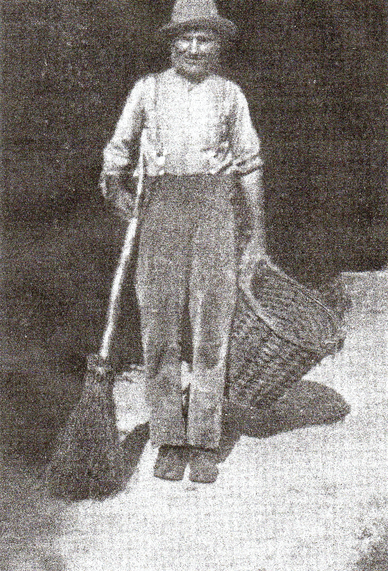As early as January 1891 Sturt was considering selling the business in which his brother Frank had little interest or involvement. “The misery of being a socialist employer of labour” may have been partly meant in humour, but managing the workshop when demand for the wheelwright’s particular skills was beginning to decline with the advent of the car and new technology contributed to Sturt’s desire to leave the business. However, selling up proved to be unnecessary as Sturt was able to appoint a foreman manager – William Goatcher – to run the enterprise, allowing Sturt to join his two unmarried sisters, Mary and Susan, at Vine Cottage in the Bourne and concentrate on writing. It was here that Sturt came across Fred Grover (Bettesworth) and his epileptic wife Lucy whose traditional way of life as ‘cottagers’ Sturt described with understanding and humour in the ‘Bettesworth’ books. Fred (pictured left) worked on and off as a gardener for Sturt at Vine Cottage where he entertained his employer with his “pleasant garrulity” and “queer anecdotes and shrewd observations” of a way of life which was all but lost by the end of the nineteenth century. It was from these conversations, covering the period from December 1892 until Fred’s death on July 25 1905, that Memoirs of a Surrey Labourer (1907) was born. Sturt never let on to Fred that he had made him the subject of a book as this knowledge “would send him boastfully drinking about the parish and make him intolerable to his familiars and useless to any employer”. The account of Fred’s tenderness and dignity in laying out Lucy on her death bed is deeply moving.
Drawing together many of the themes touched on in his Journals, The Bettesworth Book (1901) and Memoirs of A Surrey Labourer, Change in the Village , probably Sturt’s most significant work was published in 1912. In what is perhaps a more sombre book, he contemplates in greater detail the passing of a traditional way of life with its focus on seasonal activities and such traditional skills as William Cobbett previously described in his book on cottage economy and its emphasis on thrift and self sufficiency. The upheaval in rural social structures and customs, brought about by a number of factors, such as new agricultural practices and technological advances and aggravated by the loss of cottagers access to grazing on the common land through the enclosure laws passed in the second half of the nineteenth century, is profound. Locally, the coming of the railway to Farnham (1849) the setting up of the Aldershot Garrison (1855) and, most especially, the arrival of a mains water supply accelerated the pace of change more quickly in The Bourne valley, perhaps, than in other similar communities. The area was rapidly being discovered as a ‘residential centre’. For Sturt the village is being submerged “and the old comfortable seclusion lost. Even the obscurity of winter evenings does not veil that truth; for where but a few years ago, the quiet depths of darkness were but emphasized by a few glimmering cottage lights, there is now a more brilliant sparkling of lit-up villa windows”. Instead of being one of a group of villagers “tolerably independent of the rest of the world”, the men and women of the valley are increasingly dependent on competing for and acquiring regular, stable employment much of which the newly arrived, leisured middle class were able to provide, often, Sturt suggests, with some ill grace and a lack of understanding or empathy with the old ways. Traditional sources of employment in the hop gardens, gravel pits and harvest work are giving way to building work and labouring on the roads and railways, with young girls seeking ‘a little place for a start in domestic service ‘ and many young boys getting jobs in the town, often as errand boys.
It must have been hard for Sturt to react to the changing situation without some degree of ambivalence. Life for +‘the cottagers’ was hard, although real destitution was rare and Sturt is quick to point out that there was nothing of the rural idyll, so beloved of some poets, about life in the valley. The rural, or peasant tradition had deep roots. Lucy Bettesworth is described as “a dreadful apparition of poverty from the middle ages” while Sturt describes a local man, well known to him as “adapting himself so far as suited him to a more commercial economy” but not being out of place had he been transferred back to the eighteenth century.
With hindsight, we have the advantage over Sturt of knowing how these changes played out; for him the consequences of ‘eviction’ from the age old peasant way of life were unknown but inevitable “We have a people in whom the pride of life has broken down: a shattered community; a living engine whose fly-wheel of tradition is in fragments and will not revolve again” The move towards a wage- earning environment brought with it a new leisure but the villagers could find few ways in which to use the spare hours at the end of a long day spent on monotonous and mentally undemanding labour. Speaking of a coal-haulier known to him, Sturt suggests wryly that his “experience of life cannot have done great things for him”.
There are signs, however, of a growing engagement with the church, the press and politics. Speaking with him sometime later, the coal-haulier is able to talk not only of his work but of the wider aspects of the coal industry and other events reported in the national newspapers. It is this “rocess of self unfolding” that convinces Sturt that the period of change was by no means over and that greater changes were yet to come with the poor, “helped a little, or hindered a little by outsiders”, steadily but unconsciously, moving along a course of their own making. At the time of writing (1912), the first world war and the social impacts that would bring could hardly have been foreseen, although these may largely have done no more than hastened the rural upheaval chronicled by Sturt.
In his Introduction to A small boy in the sixties, Arnold Bennet records Sturt’s partial recovery from an initial stroke to be followed in 1920 by a second. Demonstrating something of the fatalism he saw in the cottagers, Sturt wrote to Bennett “I can scarcely move across the room now.... and an hour’s chatter reduces me to mumbling. But I giggle a good deal; keep cheerful; and am enjoying life intensely”. In 1922 he suffered a further blow with his sister Mary ‘s death.
Suggesting that his books may be read for his mastery of fact or to challenge our received view of ourselves (or both) David Gervais asks in his essay on Sturt in Literary Englands (1993), “Has any English writer known his own particular England as closely as Sturt knew his”

Sturt’s publications; A Year’s Exile 1898, The Bettesworth Book 1901, Memoir of a Surrey Labourer 1907, The Ascending Effort 1910, Change in the Village 1902, Lucy Bettesworth 1913, William Smith Potter & Farmer 1790-1858 1920, A Farmer’s Life 1922, The Wheelwright’s Shop 1923, A Small Boy in the Sixties 1927.
The Journals 1890-1902 published 1930, and 1890-1927 (2 volumes: edited E.D Mackerness) 1967.

Richard Sandars

