**Standing Order Mandate for The Bourne Conservation Group**

To The Manager

Bank Name………………………………………………………..

Bank Address……………………………………………………..

……………………………………………………………………..

Postcode……………………….Sort Code………………………

Please Pay: Bank Name: HSBC

Branch: Farnham Sort Code: 40-21-05

For the Credit of:

Account Name: The Bourne Conservation Group

Account No.:41547003

The Sum of: ten pounds (£10) being the annual subscription, at once and thereafter ANNUALLY on 1st June until further notice. This instruction cancels any previous order in favour of the above-named beneficiary under this reference.

Account to be Debited:

Account Name……………………………………………..........

Account Number…………………………………………….......

Signed…………………………................................................

Dated……………………..

Your address………………………………………………........

…………………………………………………………………..

…………………………………………………………………..

…………………………………………………………………..

Please return the completed form with your application to the Membership Secretary who will forward it to your Bank

***At work in The Bourne***



**Make a Difference**

**by joining as a Friend**

***The Group carries out an extensive year-round programme of work to improve the landscape of The Bourne, balancing what is attractive to residents with the needs of the rich variety of wildlife present in the area. You are encouraged to join as a Friend and to lend your support to both the work and the wider aims and aspirations of the Group***.

Although entirely a volunteer organisation, all work is carried out in a thoroughly responsible and professional way. Since 2002 when the Group was formed, considerable expertise has been developed and this is reinforced by close collaboration with official conservation bodies such as the Surrey Wildlife Trust, RSPB and relevant departments of the local authorities.

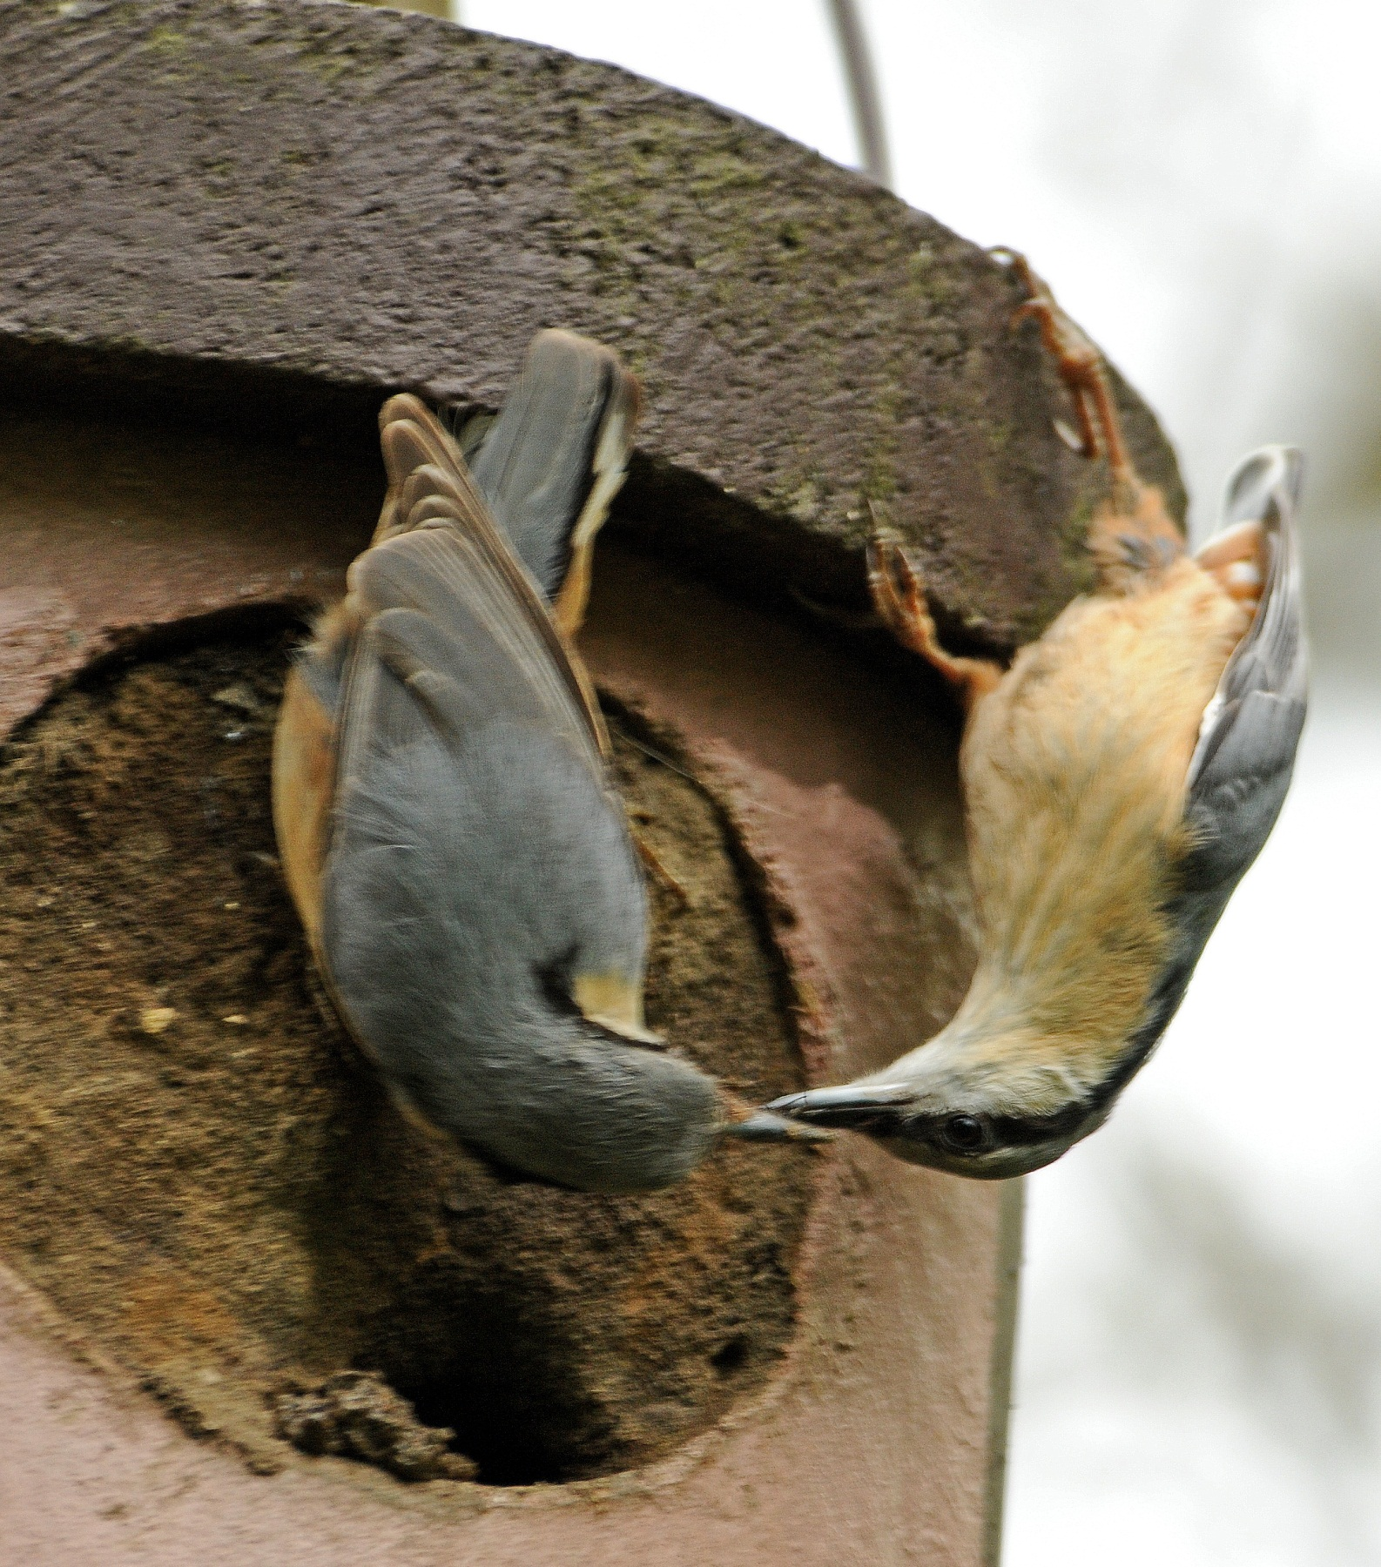



**Looking after our footpaths**

***Wildlife***

The Bourne Conservation Group is achieving impressive results in the following fields:

* Biodiversity projects as in the Middle Bourne Lane Garden
* Heritage projects including The Old Churchyard
* Footpath maintenance
* Woodland management
* Control of invasive species such as Himalayan Balsam
* Public awareness presentations and displays

The hard work is carried out by an enthusiastic core of active members who give of their time to contribute to the community. In so doing they get plenty of exercise and make new friendships. They also learn about wildlife and its habitats as well as developing new skills. For full up-to-date information and background please see:

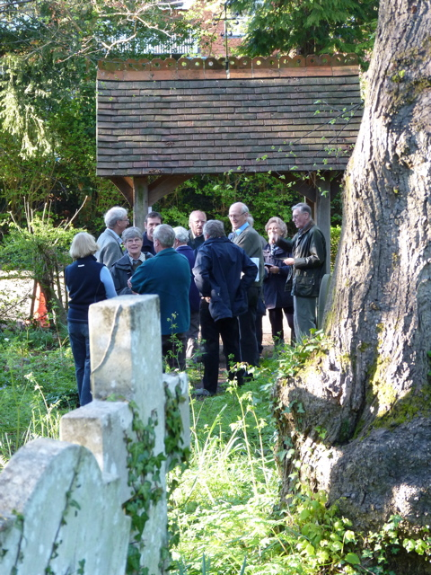

**www.bourneconservation.org.uk**

While there is always a place for new members to help with this work there is also a very real need for the backing of Friends who are prepared to support the Group in spirit and financially. Over and above the cost of the project work, there are overheads to be met for insurance, training, website, tools, display materials and incidentals. The subscription to become a Friend is £10 per annum.

***Heritage Tour***

As a Friend you become a full member of the Group. You will receive the Annual Report and three newsletters a year together with occasional Updates on live issues. There may also be opportunities to attend external seminars or workshops on subjects of conservation interest.

To join please fill in the attached application and return it to the address shown. If you have any questions please ring Karen Redman on 01252 723408 or use:

**info@bourneconservation.org.uk**

**Application for Membership as a Friend of**

**The Bourne Conservation Group**

Full Name Mr/Mrs/Ms…………………………………….............

Address………………………………………………………………

…………………………………………………………………………

…….………………………Postcode……………………………….

Telephone Number…………………………………………...........

E-mail………………………………………………………………...

Subscription: £10. The annual renewal date is 1st June but membership for the following year is inclusive if you are joining after 1st January. You may either pay annually by cheque or by bank standing order. **The latter is preferable because it saves administration – you can use the adjacent form to set up a standing order.**

I enclose my subscription for £………………………

I would like to make a donation of £………………..

to The Bourne Conservation Group

I heard about BCG from………………………………

Signed……………………………..Dated:……………

Cheques should be made payable to 'The Bourne Conservation Group' and sent with this form to:

The Membership Secretary

The Bourne Conservation Group

11 Annandale Drive

Lower Bourne

Farnham, Surrey GU10 3JD